**SMART CHAIR**

Introduction

Most of the people are leaving machine life now a days. One of the most problems faced in this busy life is spinal problems. Many experiments proved that this is due to incorrect sitting posture. The complications of poor posture include spinal dysfunction, joint generation, rounded shoulders and a potbelly. So solving this issue is our main motto for the project.

Project Details

Aim:

Sitting posture correction is our main motto. We inform the user to correct his/her seating posture by alerting him using a buzzer.

We are doing this using force sensor, tilt sensor and buzzer.

Apparatus:

Force Sensor , Arduino , Bread board , Connecting wires , Buzzer , LED, Tilt Sensor

Force Sensor

A Force Sensor is defined as a transducer that converts an input mechanical load, weight, tension, compression or pressure into an electrical output signal.

Most force sensors are created with the use of force-sensing resistors. Such sensors consist of electrodes and sensing film.

Force-sensing resistors are based on contact resistance. These contain a conductive polymer film, which changes its resistance in a predictable way once force is applied on the surface.

This film includes non-conducting, micrometer sized, and electrically conducting particles, which are arranged in a matrix. If force is applied to the film’s surface, micro sized particles touch the sensor electrodes, which change the film’s resistance.

The amount of change may alter the resistance value that provides a measure of the applied force.

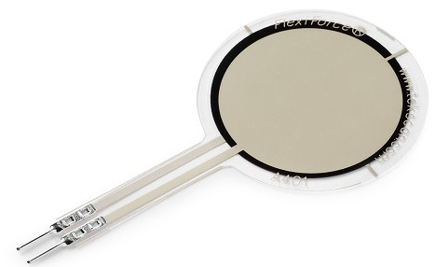

Tilt Sensors

A tilt sensor is an instrument that is used for measuring the tilt in multiple axes of a reference plane. Tilt sensors measure the tilting position with reference to gravity and are used in numerous applications. They enable the easy detection of orientation or inclination. They may also be known as tilt switches or rolling ball sensors.

A tilt sensor has a metallic ball that is designed to move the two pins of the instrument from the 'on' to the 'off' position, and vice versa, if the sensor reaches a pre-determined angle.

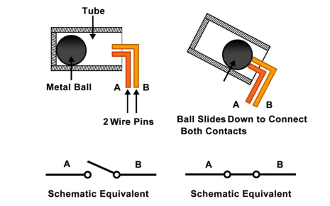

Design

For detecting the posture of the person, 5 force resistor sensors are used with 2 at the back and 3 at the base of the seat. An extra tilt sensor is also used to detect if the chair is tilted or not.

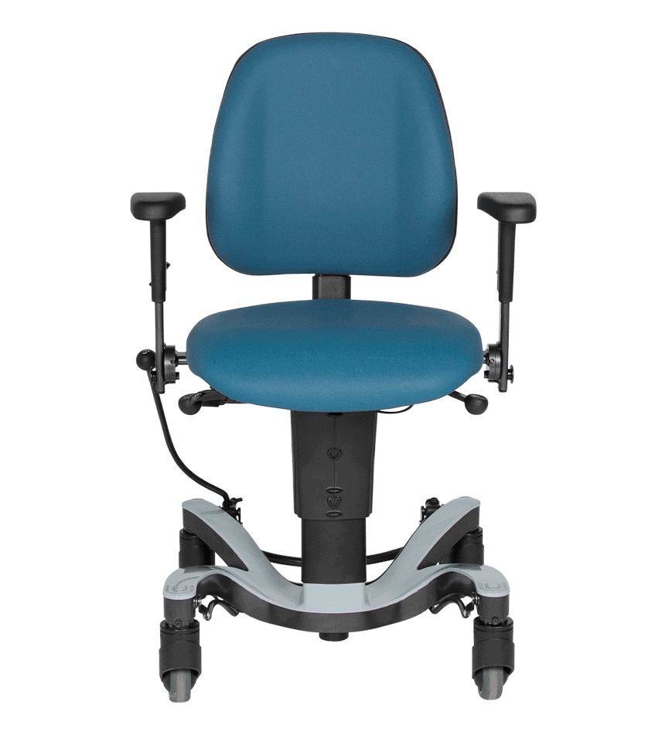

T

Tilt sensor

Force sensor



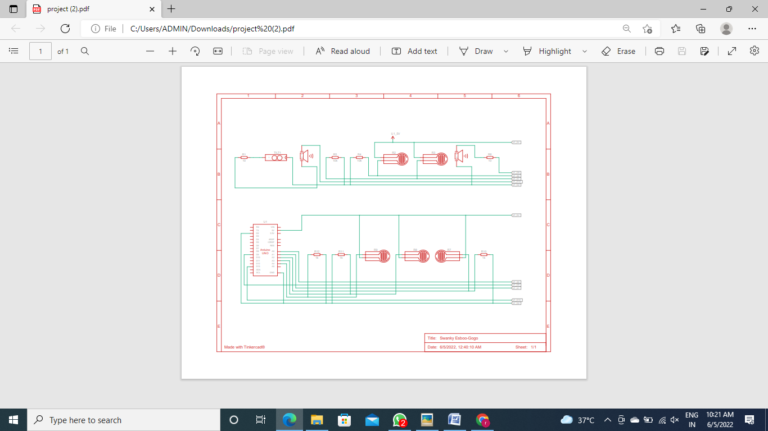

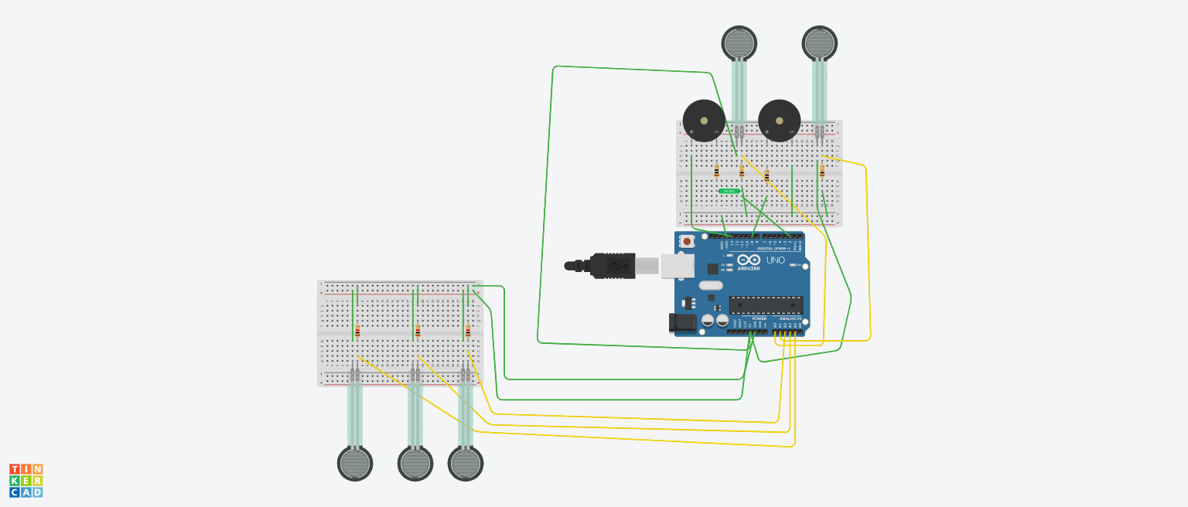

Force sensor

4

3

~~2~~

1

0

Tilt sensor

Working:

The basic working is that if a person sits in the wrong posture for more than 5 minutes, he is alerted to correct his position with the help of a buzzer. The buzzer rings after every 5 minutes until the person corrects his posture. The buzzer will buzz if all the sensors are not on at the same time.

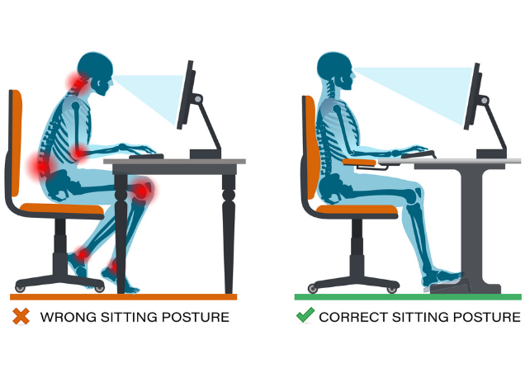

In the above sitting posture, the force resistors 0, 1 and 4 will offer infinite resistance as the force is not applied on them. Hence, the buzzer will buzz if the person doesn’t correct his position within 5 minutes.

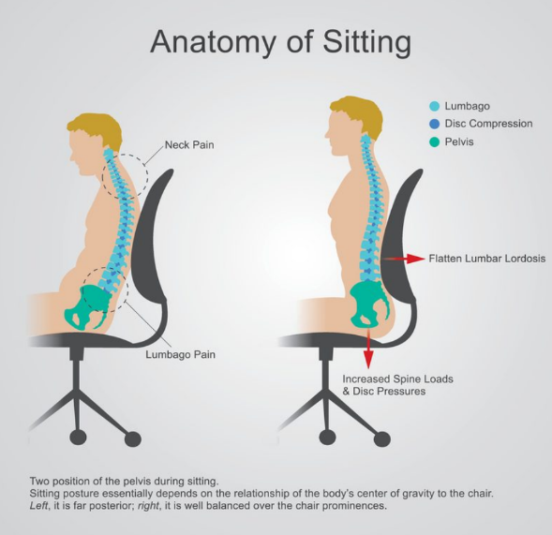

Here the force resistor 2 will offer infinite resistance. Hence the buzzer sounds.



In this case, the tilt sensor will be on, and the buzzer buzz indicating wrong posture.



If any of the 5 force sensors are not pressed then it indicates a wrong seating posture. If none of them are pressed, then it means that no one is using the chair.

Conclusion

With our knowledge of Arduino and sensors we tried to use a buzzer which says whether our posture is correct or not.

*Our further research will be on adjusting the back pillow by expanding and contracting (which is just like the airbags in the car) based on sensing the person’s posture until it touches his body. This will really help lot of old people and physically handicapped people. We the future Engineers believe that our research and projects in future must help the society in any way and we believe that’s our duty.*